**1.Project Title:**

**Online Job portal System**

**2.Introduction:**

A Job Portal System is a web based application designed to connect job seeker with employers.The platform allows job seekers to browe and apply for jobs, while emplyers can post job listing and review application.The system facilitsates the recruitment process by providing features such as resume uploads,job filtering and application tracking.

**3.Objectives:**

* .To provide a centralized platform for job seeker and recruiters.
* .To enable job seeker to search apply,and track job applications.
* .To allow employers to post job vacancies and manage applications.
* .To simplify the hiring process using automated workflows.
* .To provide filters for searching jobs based on skilles,experience, and location.

**4.Features:**

**For Job seekers:**

* User registration and profile creation.
* Resume upload and management.
* Job search with filters.
* Job application submission and tracking.

**For employers:**

* Employers registrastion and profile creation.
* Job posting and management
* Searching and filtering applicats based on skills and experience.
* Reviewing resumes and contacting candidates.

**Admin panel:**

* Managing users(job seekers and employers)
* Approving or rejecting job postings
* Generating and analytics and reports on job trends

**5.Technology stack:**

* Frontend: HTML,CSS,javascript
* Backend: PHP
* Database: MYSQL

**6.Expected outcome:**

* A functional job portal with an interactive UI.
* A dynamic job search feature to improve user experience.
* Data insights for admin to analyze job market trends.

**Scope and Features of Job Portal Project**

The Job Portal System aims to streamline the job search and recruitment process by providing a unified platform where job seekers and employers can interact efficiently.

Scope Includes:

**1.User Authentication & Role-Based Access**

* Job seekers, employers, and admins will have different access levels.
* Secure login and registration with email/password or third-party OAuth (Google, LinkedIn, etc.).

• Password reset and account verification.

1. **Job Seeker Functionalities**

* Profile creation with personal details, skills, and experience.
* Resume upload and management.
* Search jobs using filters (category, location, salary, experience, company).
* Save jobs for later applications.

1. **Employers Functionalities**

* Profile setup with company details.
* View and manage job application.

**III.Admin pannel**

* Approve or reject job postings.

**MODULES:**

A job portal system consist of multiple modules.

**1**.**User management module**

**Functionalities:**

* User registration (job seekers,employers and admins.)
* Login/logout system.
* Profile management(update name, email, contact info,profile picture, etc.)
* Forgot password and account recovery.

**2.Admin Management Module**

**Functionalities:**

* Manage users(active/deactivate accounts).
* Moderate job postings(approve/reject).
* View site analytics and reports.

**3.Job seeker module:**

**Functionalities:**

* Profile creation and editing.
* Upload resume and manage documents.
* Apply for jobs.
* Track application status.

**4.Employer Module**

**Functionalities:**

* Company profile creation.
* Post job listings.
* Edit or delete job listing.
* View applications received.
* Contact applicants.

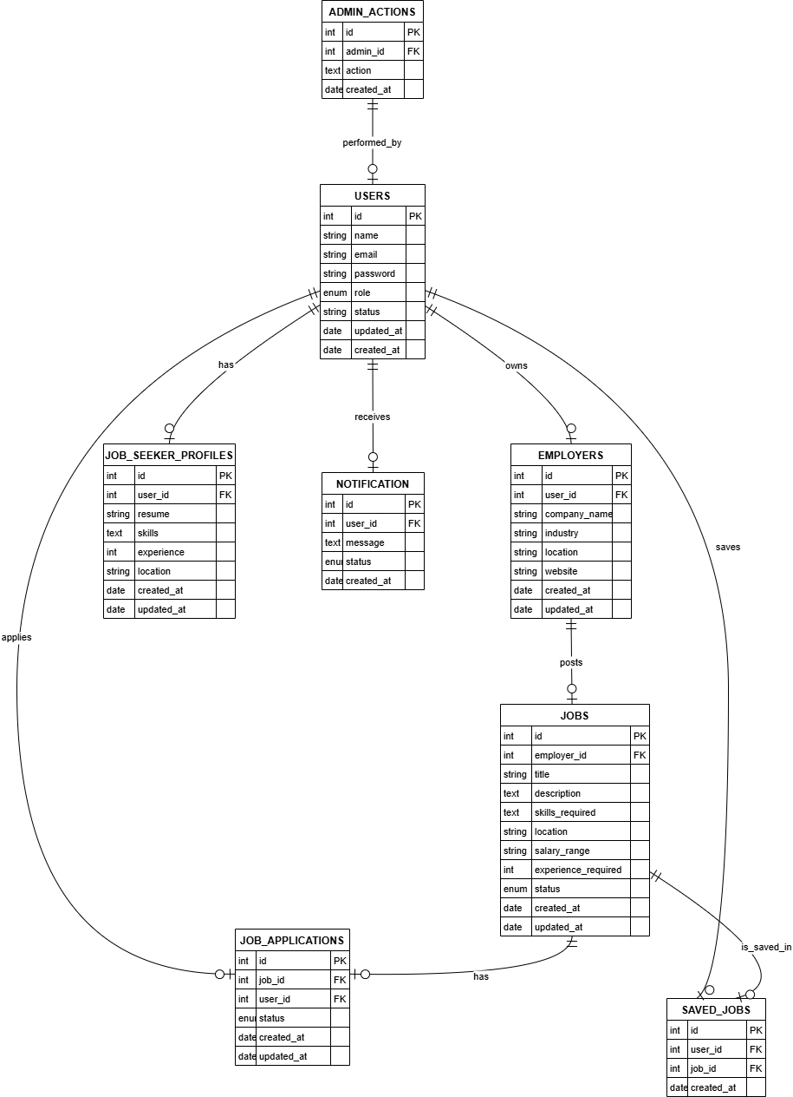**ER DIAGRAM**:

**Data Flow Diagram:**

**DFD LEVEL 0**

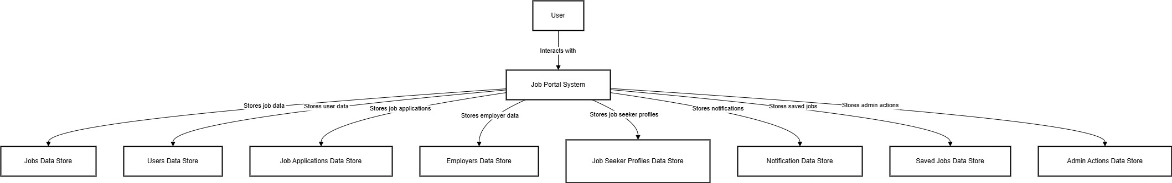

DFD level 2

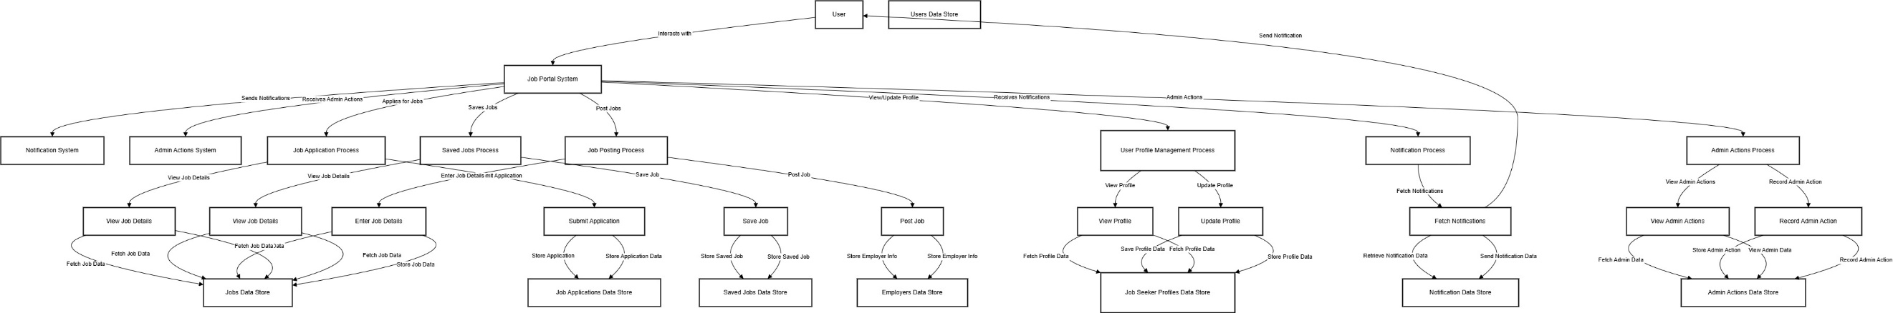

**DFD LEVEL2**

**DFD LEVEL 1**

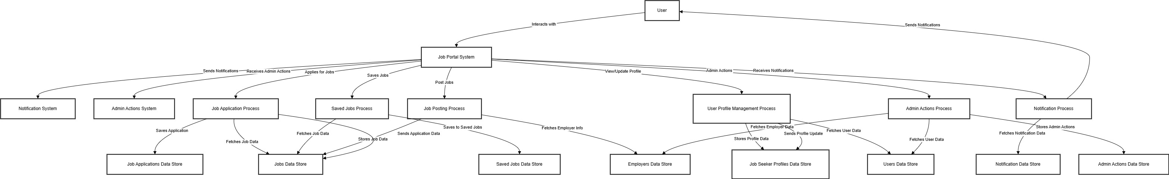

**Conclusion:**

This Job Portal System consists of 4 main module that collectively allow job seekers and employers to interact efficiently.Each module has its own functionalities and corresponding database tables to store structured data.The admin panel ensures smooth operation by managing user activities and moderating job posting.